Point–Ray Collinearity
# Source: AI Source: Provided by: [Data Path: Persons Table -> ID Column: 1, Name_En Column: Motasem Essam] -> From: [ChatGPT] on [7/25/2026]
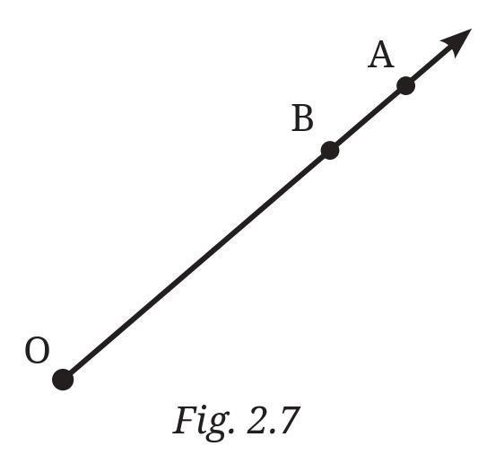
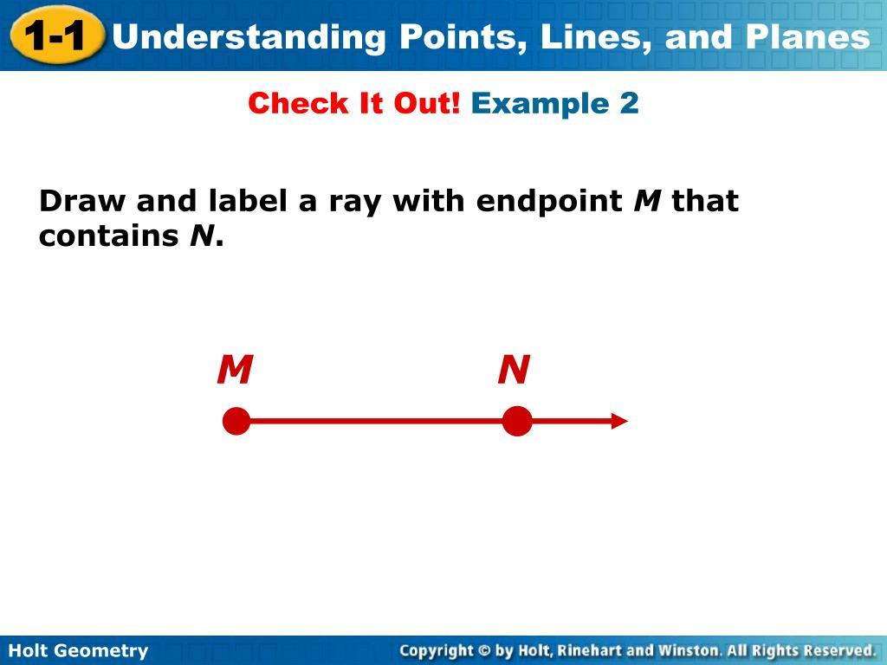
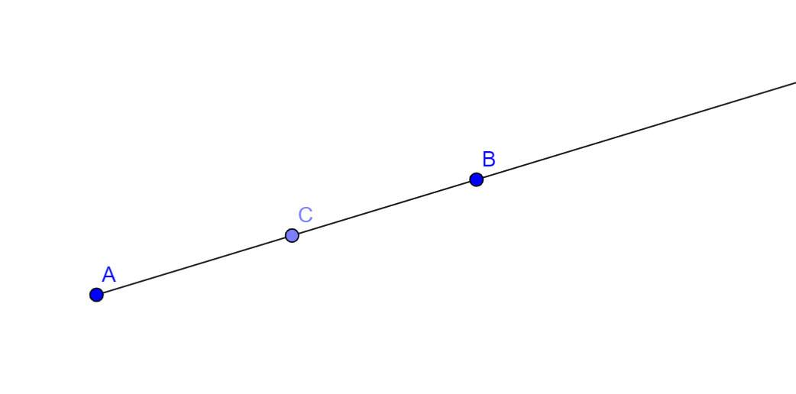

Definition
# Source: AI Source: Provided by: [Data Path: Persons Table -> ID Column: 1, Name_En Column: Motasem Essam] -> From: [ChatGPT] on [7/25/2026]
Point–Ray Collinearity is a geometric relationship in which a point and a ray lie on the same supporting straight line.
For a point $P$and a ray $\vec{AB}$, they are point–ray collinear if there exists a line $l$such that:
$$P∈l$$
and
$$\vec{AB}⊆l$$
Therefore, $P$, $A$, and $B$lie on the same straight line.
The important point is that collinearity does not necessarily mean that $P$belongs to the ray itself.

Basic Representation
# Source: AI Source: Provided by: [Data Path: Persons Table -> ID Column: 1, Name_En Column: Motasem Essam] -> From: [ChatGPT] on [7/25/2026]
Point on the Ray
A ●────────● P──────────────● B──────────────▶
Here:
$$P∈\vec{AB}$$
so $P$is both collinear with and contained in the ray.
Point Outside the Ray
P ●──────A ●──────────────B──────────────────▶
Here:
$$P∈\overset{↔}{AB}$$
but:
$$P∉\vec{AB}$$
The point and ray are nevertheless collinear because they share the same supporting line.

Fundamental Concept
# Source: AI Source: Provided by: [Data Path: Persons Table -> ID Column: 1, Name_En Column: Motasem Essam] -> From: [ChatGPT] on [7/25/2026]
A ray has:
- An endpoint
- A direction
- Infinitely many points extending in one direction
For:
$$\vec{AB}$$
the point $A$is the endpoint and the ray extends from $A$through $B$indefinitely.
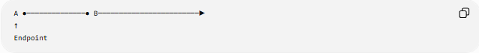
A ●──────────────● B────────────────────────▶
↑
Endpoint
The supporting line is:
$$\overset{↔}{AB}$$
and the ray is only one half of that line.
Therefore:
$$\vec{AB}⊂\overset{↔}{AB}$$

Point on the Ray vs. Point Collinear with the Ray
# Source: AI Source: Provided by: [Data Path: Persons Table -> ID Column: 1, Name_En Column: Motasem Essam] -> From: [ChatGPT] on [7/25/2026]
These concepts should be distinguished.
Point on the Ray
$$P∈\vec{AB}$$
The point is in the ray itself.
Point Collinear with the Ray
$$P∈\overset{↔}{AB}$$
The point lies on the ray's supporting line.
It may or may not belong to the ray.
Therefore:
$$\boxed{P∈\vec{AB}⇒P\text{ is collinear with }\vec{AB}}$$
but:
$$\boxed{P\text{ collinear with }\vec{AB}⇏P∈\vec{AB}}$$

Types of Point–Ray Position
# Source: AI Source: Provided by: [Data Path: Persons Table -> ID Column: 1, Name_En Column: Motasem Essam] -> From: [ChatGPT] on [7/25/2026]
For ray $\vec{AB}$, a collinear point $P$can occur in several positions.
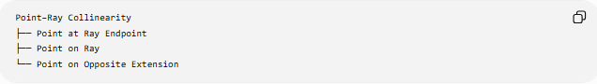
Point–Ray Collinearity
├── Point at Ray Endpoint
├── Point on Ray
└── Point on Opposite Extension

1. Point at the Endpoint
# Source: AI Source: Provided by: [Data Path: Persons Table -> ID Column: 1, Name_En Column: Motasem Essam] -> From: [ChatGPT] on [7/25/2026]
P=A ●────────────B────────────────▶
$$P=A$$
Therefore:
$$P∈\vec{AB}$$

2. Point on the Ray
# Source: AI Source: Provided by: [Data Path: Persons Table -> ID Column: 1, Name_En Column: Motasem Essam] -> From: [ChatGPT] on [7/25/2026]
A ●────────P ●────────B────────────▶
$$P∈\vec{AB}$$

3. Point on the Opposite Extension
# Source: AI Source: Provided by: [Data Path: Persons Table -> ID Column: 1, Name_En Column: Motasem Essam] -> From: [ChatGPT] on [7/25/2026]
P ●────────A ●────────B────────────▶
Here:
$$P∈\overset{↔}{AB}$$
but:
$$P∉\vec{AB}$$
The point is still collinear with the ray.

Coordinate Representation
# Source: AI Source: Provided by: [Data Path: Persons Table -> ID Column: 1, Name_En Column: Motasem Essam] -> From: [ChatGPT] on [7/25/2026]
Let:
$$A=\left(x_{1} , y_{1}\right)$$
and:
$$B=\left(x_{2} , y_{2}\right)$$
The ray can be represented parametrically as:
$$r\left(t\right)=A+t\left(B-A\right)$$
with:
$$\boxed{t≥0}$$
The condition $t≥0$identifies points belonging to the ray.
For a point $P$:
$$P=A+t\left(B-A\right)$$
Position determined by $t$
$$t$$ | Position
$$t<0$$ | Opposite extension of the ray
$$t=0$$ | Ray endpoint $A$
$$t>0$$ | On the ray
Thus, collinearity allows any real $t$, while ray containment requires:
$$t≥0$$

Coordinate Example
# Source: AI Source: Provided by: [Data Path: Persons Table -> ID Column: 1, Name_En Column: Motasem Essam] -> From: [ChatGPT] on [7/25/2026]
Let:
$$A=\left(2 , 3\right)$$
and:
$$B=\left(6 , 3\right)$$
The ray is:
$$\vec{AB}$$
and extends along:
$$y=3$$
Example 1
$$P=\left(10 , 3\right)$$
Since $P$lies in the same direction from $A$through $B$:
$$P∈\vec{AB}$$
Therefore $P$is on the ray.
Example 2
$$P=\left(- , 23\right)$$
This point lies on the same supporting line:
$$y=3$$
but it lies in the opposite direction from $A$.
Therefore:
$$P∈\overset{↔}{AB}$$
but:
$$P∉\vec{AB}$$
It is nevertheless point–ray collinear.

Collinearity Test
# Source: AI Source: Provided by: [Data Path: Persons Table -> ID Column: 1, Name_En Column: Motasem Essam] -> From: [ChatGPT] on [7/25/2026]
For:
$$A=\left(x_{1} , y_{1}\right), B=\left(x_{2} , y_{2}\right), P=\left(x_{3} , y_{3}\right)$$
the three points are collinear when:
$$\boxed{\left(x_{2}-x_{1}\right)\left(y_{3}-y_{1}\right)-\left(y_{2}-y_{1}\right)\left(x_{3}-x_{1}\right)=0}$$
This establishes that $P$lies on the ray's supporting line.
To additionally determine whether $P$lies on the ray, the direction must also agree with the ray:
$$P=A+t\left(B-A\right)$$
with:
$$\boxed{t≥0}$$

Point–Ray Incidence and Containment
# Source: AI Source: Provided by: [Data Path: Persons Table -> ID Column: 1, Name_En Column: Motasem Essam] -> From: [ChatGPT] on [7/25/2026]
When:
$$P∈\vec{AB}$$
the point has several simultaneous relationships with the ray:
- Point–Ray Collinearity
- Point–Ray Incidence
- Point–Ray Containment
But if:
P ●────A ●────B────────────────▶
then $P$is collinear with the ray but is not contained in the ray.
This distinction is important for your taxonomy.

Point–Ray Collinearity vs. Point–Segment Collinearity
# Source: AI Source: Provided by: [Data Path: Persons Table -> ID Column: 1, Name_En Column: Motasem Essam] -> From: [ChatGPT] on [7/25/2026]
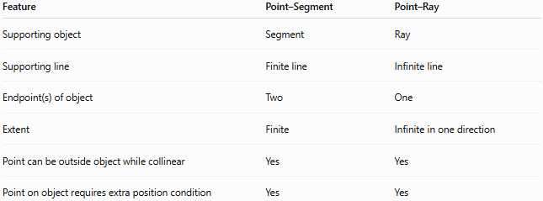
Feature | Point–Segment | Point–Ray
Supporting object | Segment | Ray
Supporting line | Finite line | Infinite line
Endpoint(s) of object | Two | One
Extent | Finite | Infinite in one direction
Point can be outside object while collinear | Yes | Yes
Point on object requires extra position condition | Yes | Yes
For a segment:
$$0≤t≤1$$
For a ray:
$$t≥0$$
For the entire supporting line:
$$t∈R$$
This provides a useful unified representation:
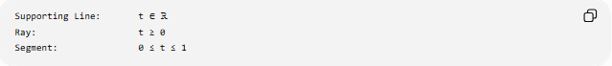
Supporting Line: t ∈ ℝ
Ray: t ≥ 0
Segment: 0 ≤ t ≤ 1

Important Properties
# Source: AI Source: Provided by: [Data Path: Persons Table -> ID Column: 1, Name_En Column: Motasem Essam] -> From: [ChatGPT] on [7/25/2026]
- A point–ray collinearity relationship requires a common supporting line.
- The point does not necessarily have to lie on the ray itself.
- Every point belonging to a ray is collinear with that ray.
- A point on the opposite extension is collinear with the ray but is not contained in it.
- The endpoint of the ray is collinear with the ray.
- A ray has infinitely many points in its direction.
- The supporting line contains both the ray and its opposite extension.
- Point–ray collinearity is symmetric as a geometric alignment relationship.
- Point–ray containment is more restrictive than point–ray collinearity.
- A ray and its supporting line are not the same geometric object.

Comparison with Point–Line Collinearity
# Source: AI Source: Provided by: [Data Path: Persons Table -> ID Column: 1, Name_En Column: Motasem Essam] -> From: [ChatGPT] on [7/25/2026]
A line extends infinitely in both directions, whereas a ray extends infinitely in only one direction.
For a line:
$$P∈\overset{↔}{AB}$$
is sufficient to establish that $P$lies on the line.
For a ray:
$$P∈\vec{AB}$$
requires both:
- Collinearity with $A$and $B$
- Correct direction from $A$through $B$
Therefore, point–ray containment has an additional directional condition that point–line containment does not.

Key Points
# Source: AI Source: Provided by: [Data Path: Persons Table -> ID Column: 1, Name_En Column: Motasem Essam] -> From: [ChatGPT] on [7/25/2026]
- Point–Ray Collinearity means a point and a ray lie on the same supporting straight line.
- The point may be:
  - at the ray's endpoint,
  - on the ray,
  - or on the opposite extension.
- For a point actually to belong to the ray:
$$P=A+t\left(B-A\right), t≥0$$
- Collinearity alone does not establish that the point belongs to the ray.
- Point–ray collinearity belongs under Line-Object Collinearity.

Conclusion
# Source: AI Source: Provided by: [Data Path: Persons Table -> ID Column: 1, Name_En Column: Motasem Essam] -> From: [ChatGPT] on [7/25/2026]
Point–Ray Collinearity describes the common straight-line alignment between a point and a ray. Because a ray has a specific endpoint and direction, it is important to distinguish being collinear with the ray's supporting line from actually belonging to the ray. This makes point–ray collinearity a useful bridge between the broader concept of collinearity and the more restrictive concepts of incidence and containment.

